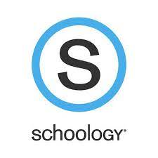
- Go to bcps.schoology.com
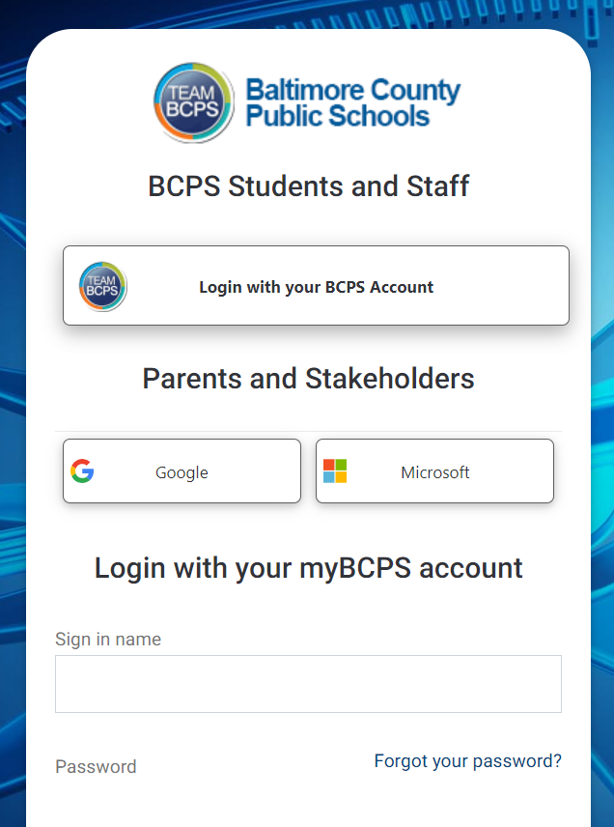
- Choose Login with your BCPS Account
- Enter username@bcps.org
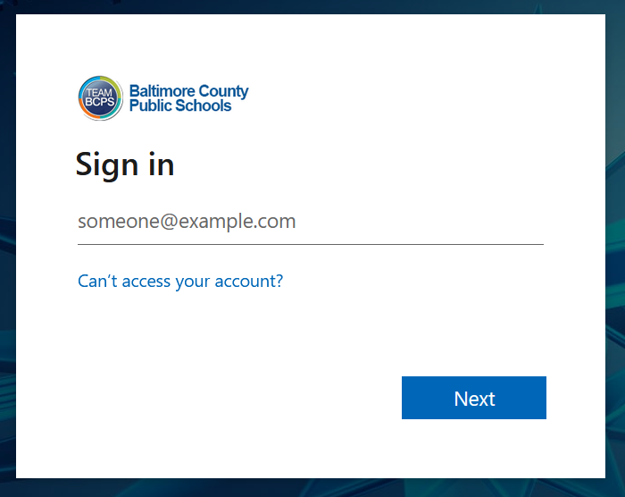
- Enter password
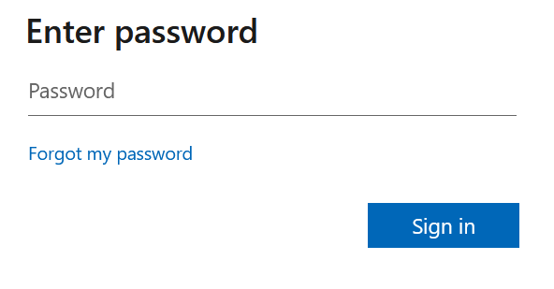

- Go to COURSES
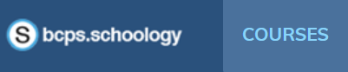

- Choose At Home Learning course
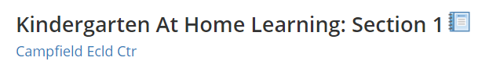

- Select daily folders
